**COMPUTER SCIENCE DEPARTMENT**

Computer Organization and Assembly language

**Lab Task # 04**

**Last date of Submission: 17th March 2024**

# Submitted To: Sir Ahmed Saleem Khattak

**Student Name: UBIAD-BIN-WARIS**

# Reg. Number: 2212416

# 

**Code: 01**

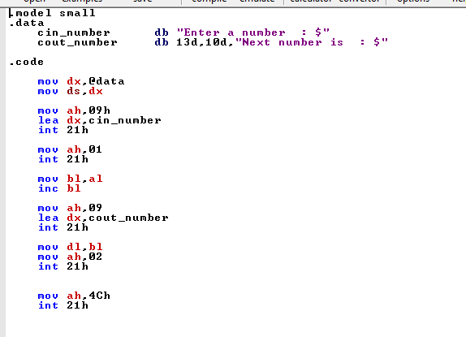

**Output**

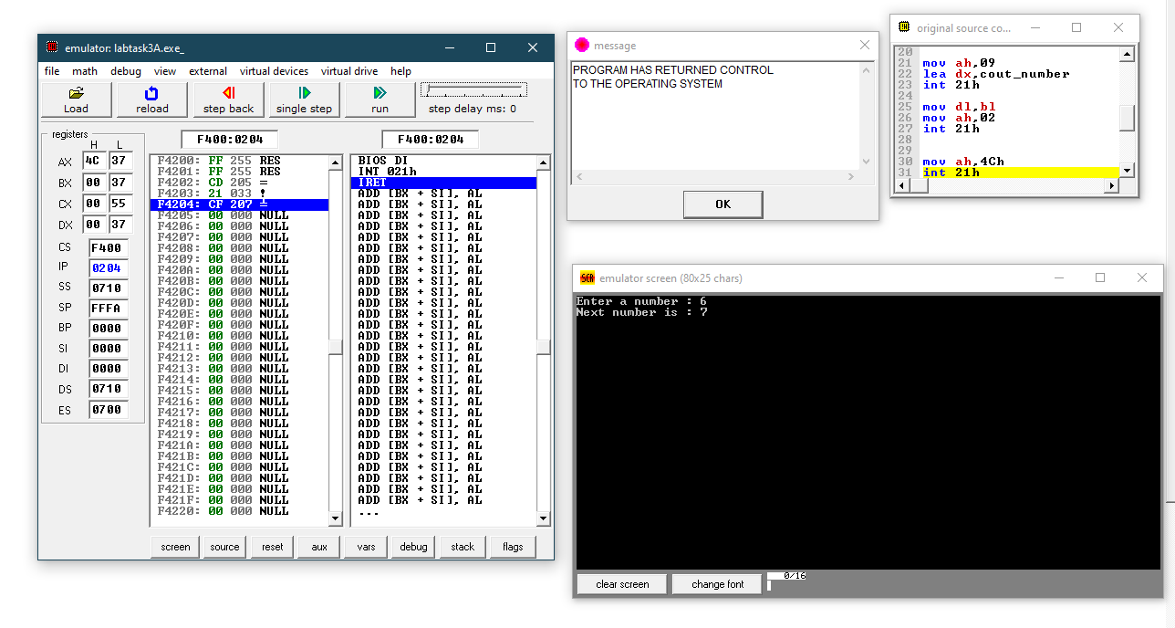

**Code: 02**

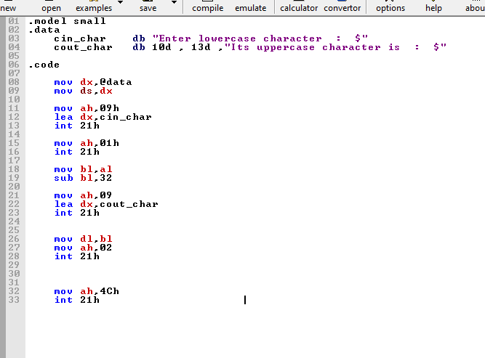

**Output**

